Posting Date: 15th Jan 2025
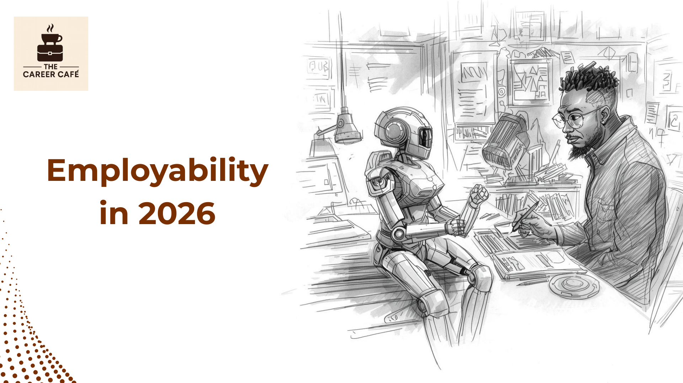

Employability in 2026: The Skills Professionals Can’t Afford to Ignore
Employability is no longer about how good you are at your job.
It’s about how relevant you remain as the job changes.
This year, most professionals will not be competing against machines. They will be competing against other professionals who know how to work with them. This distinction matters because it shifts the employability conversation from fear to strategy.
For years, career conversations have focused on qualifications, titles, and years of experience. Those still matter, but they no longer guarantee security.
Roles are evolving faster than formal job descriptions can keep up, and organizations are increasingly hiring for adaptability, judgment, and learning capacity rather than static expertise.
The question professionals must now ask is not “What do I do?” but “How do I continue to add value as the context changes?”

The Employability Myth: Skills Alone Are Enough
There is a persistent myth that employability is solved by collecting more technical skills. Learn a new tool. Earn a new certificate. Add another line to your CV.
While technical skills are important, they depreciate quickly. Tools change. Platforms evolve. Entire functions are restructured. Professionals who rely solely on technical competence often find themselves repeatedly playing catch-up.
What separates employable professionals from vulnerable ones is not how many skills they possess, but how they think, communicate, and apply judgment in complex environments.
This perspective aligns with recent thinking shared in a Forbes analysis by Carmine Gallo on the one skill professionals cannot afford to ignore as AI reshapes the workplace.
The core argument is clear: as machines take over routine tasks, human-centred skills - especially communication, reasoning, and meaning-making - become the real differentiators.
In short, employability is becoming more human, not less.

The Skill That Sits Above All Others
If there is one capability that underpins employability in 2026, it is the ability to think clearly and communicate meaningfully in uncertain, AI-augmented environments.
This is not about being a charismatic speaker or a polished presenter. It is about sense-making.
Professionals who remain employable are those who can:
- Interpret information, not just process it
- Ask better questions when answers are automated
- Explain complex ideas clearly to different audiences
- Exercise judgment where systems cannot
AI can generate content, analyze data, and automate workflows. What it cannot do reliably is decide what matters, why it matters, and how to act responsibly in context. That responsibility increasingly sits with humans.

Employability Is Shifting From Execution to Judgment
Many roles are quietly changing in nature. Tasks that once required manual effort are now supported, or replaced, by systems. As a result, the human contribution shifts upward.
Professionals are expected to:
- Frame problems rather than simply solve predefined ones
- Evaluate outputs rather than generate them from scratch
- Make trade-offs in ambiguous situations
- Translate insights into action across teams
This is why strong performers sometimes struggle when promoted or when technology is introduced. Execution alone is no longer sufficient. Judgment, context, and communication become central.
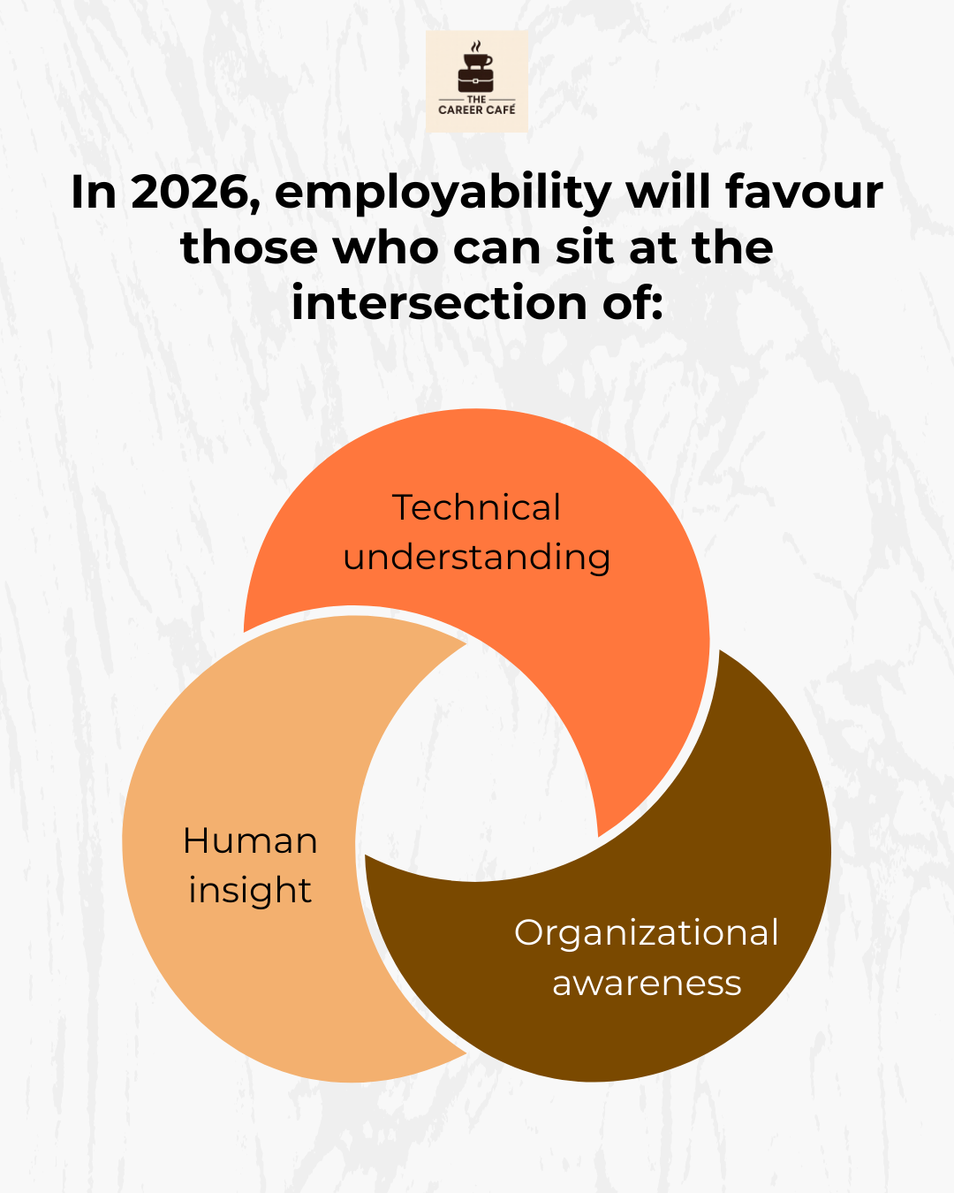

The Overlooked Skill: Learning How to Learn
One of the most underestimated employability skills is learning velocity.
Employable professionals are not those who already know everything. They are those who can acquire new knowledge quickly, apply it responsibly, and let go of outdated assumptions.
This requires humility. It also requires structure.
Learning in 2026 will be less about formal retraining and more about continuous recalibration:
- Identifying which skills are becoming less valuable
- Investing early in adjacent capabilities
- Practising reflection, not just consumption
Professionals who wait until a role is threatened to start learning are already behind. Those who build learning into their routines remain adaptable without panic.

Why Communication Has Become a Career Multiplier
As highlighted in the Forbes article, communication is emerging as the defining skill of the AI era, not because machines cannot communicate, but because humans must now communicate with intention.
Clear communication enables employability in several ways:
- It allows professionals to articulate value beyond tasks
- It makes expertise visible across teams and institutions
- It builds trust in environments shaped by automation
- It positions individuals as thinkers, not just doers
In practical terms, this means employable professionals can explain why a recommendation matters, not just what the data shows. They can influence decisions, align stakeholders, and provide clarity amid complexity.
This is especially critical for professionals working with global teams, cross-functional roles, or public-facing institutions.

What This Means for Institutions and Employers
Employability is not only an individual concern. Institutions that fail to invest in these skills risk building technically capable but strategically fragile workforces.
Training that focuses exclusively on tools without strengthening thinking, communication, and judgment creates dependency rather than resilience. By contrast, organizations that develop these human capabilities are better positioned to navigate change, innovation, and ethical decision-making.
From a workforce perspective, employability is a shared responsibility. Systems that prioritize learning, clarity, and adaptability benefit everyone involved.
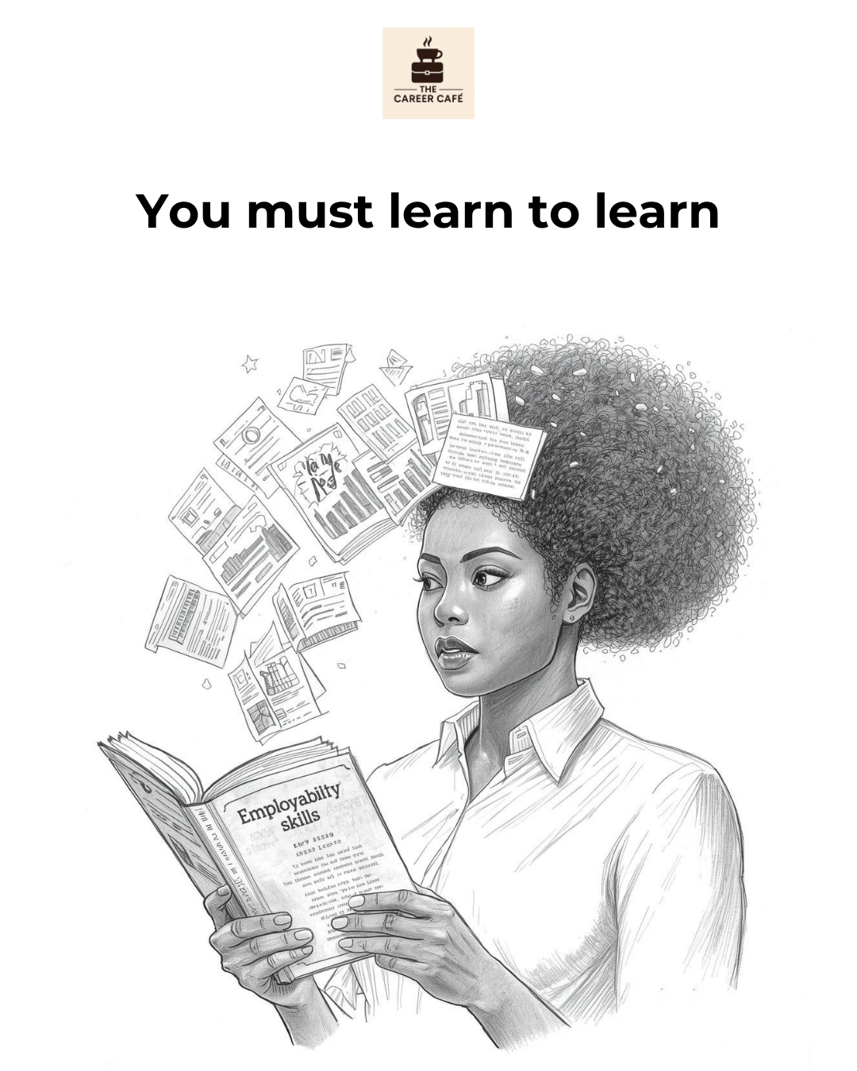

How Professionals Can Act Now?
Preparing for employability in 2026 does not require radical reinvention. It requires intentional shifts.
Start by asking:
- Can I clearly explain the value I add beyond my job description?
- Am I developing judgment, or just executing tasks?
- How often do I reflect on what I’m learning - and what I’m unlearning?
- Can I communicate complex ideas simply to different audiences?
These questions are more predictive of employability than any single technical certification.

Employability Is a Long-Term Strategy
Employability is not about staying busy. It is about staying relevant.
As AI reshapes the workplace, the most secure professionals will not be those who resist change or chase every new tool. They will be those who invest in thinking, communication, and learning - the skills that compound over time and travel across roles, sectors, and borders.
In 2026, employability will belong to professionals who understand that their greatest asset is not what they do, but how they think and contribute within evolving systems.

If AI is starting to feel less theoretical and more present in your role, the question is no longer whether change is coming - but how prepared you are for it.
Take time to assess which skills you are actively building, which ones are stagnating, and where your long-term relevance truly lies.
If this perspective is useful, share the article with a colleague or team that also needs to stay ahead as we move toward 2026.

Caption:
Let’s address the elephant in the room. Are you employable in 2026, or should you clear your desk and leave it all to AI?
AI can feel threatening, but it isn’t replacing professionals. It’s replacing tasks. And the gap between those who stay relevant and those who don’t is widening fast.
This article isn’t about fear or hype. It’s about the skills that actually protect employability as work evolves - the human capabilities that compound when tools change, and roles shift.
Read through, repost and let us know that one skill that you are intentionally building to stay relevant in the next few years?

